P.S. 108

The Philip J. Abinanti School

Charles Sperrazza Caren Shapiro

Principal Vanessa Visners Assistant Principal

Lori Solano Assistant Principal Yvette Santiago

Assistant Principal Parent Coordinator

September 25, 2013

Dear Parents:

This month’s PTA General Meeting will be held on Tuesday, October 8, 2013 beginning at 6:30 p.m**.**

**Join us for a**

**Columbus Day Parade**

**PASTA SAMPLING AND PERFORMANCE BY OUR DANCE CHEER TEAM**

The agenda for this meeting is as follows:

* *The Pledge of Allegiance*
* *Principal’s Report Mr. Sperrazza*
* *PTA Report Tania Piarulli/Angie Capozzli*
* *Treasurer’s Report Mona Oskurt*
* *Internet Safety Presentation Nikki Dixon –Hang 10 Child Safety Division*
* *We will have nominations for open seats on the SLT (****S****chool* ***L****eadership* ***T****eam)*

**We will also be having a mini Penny Social in the All Purpose Room this evening. We are taking donations for any unused unopened gifts to be raffled this evening. Send them to the PTA office with your child’s name and class.**

Please make every effort to attend this meeting. This is your opportunity to have your voice heard and to be an integral part of our school community.

Sincerely,

PTA Executive Board

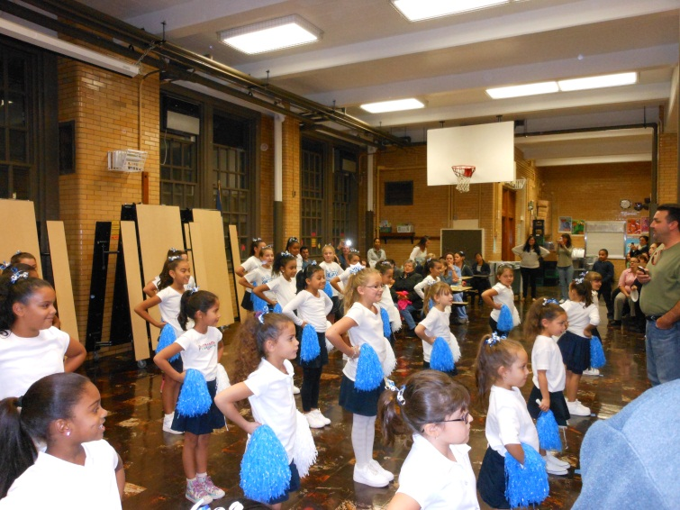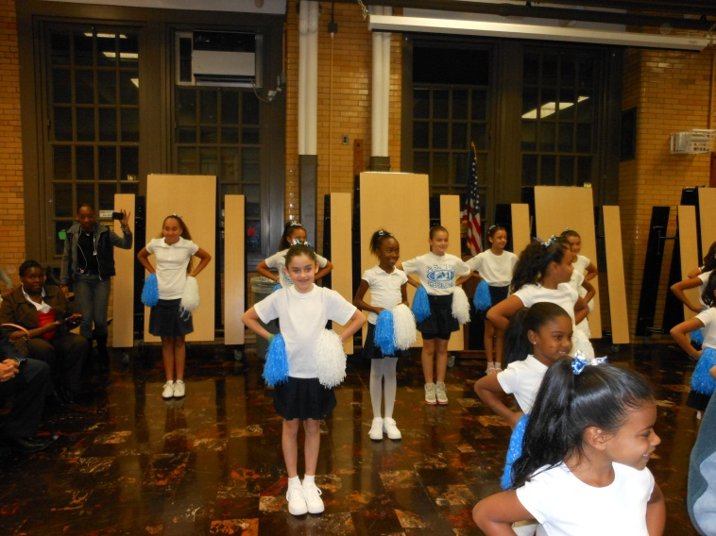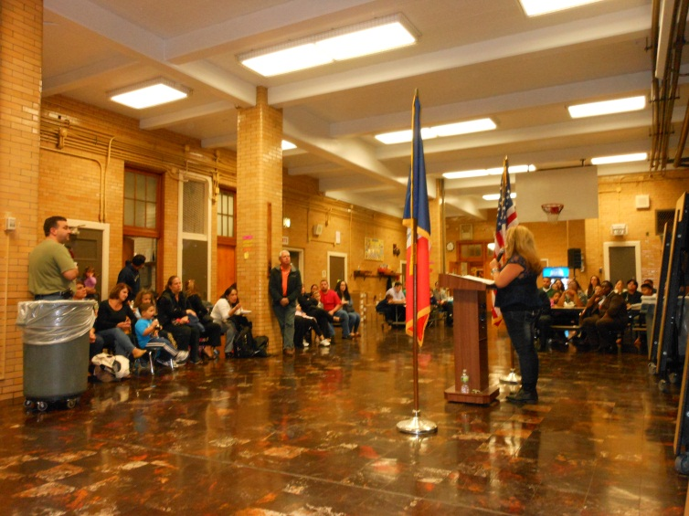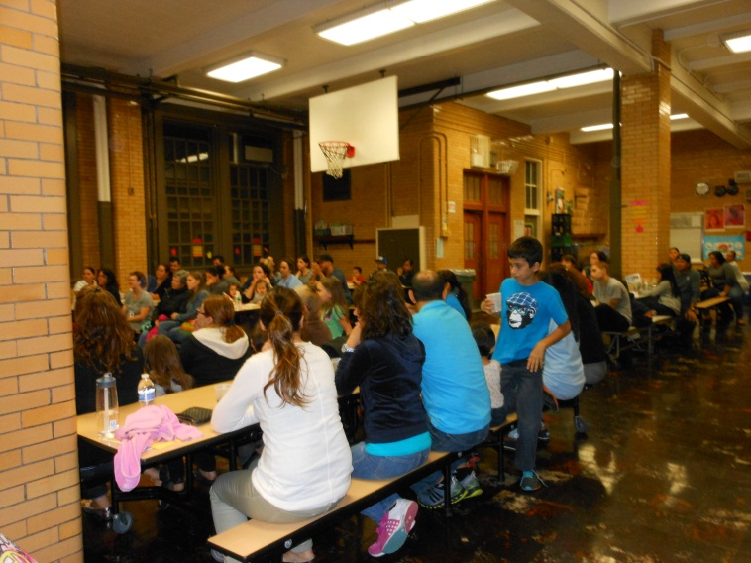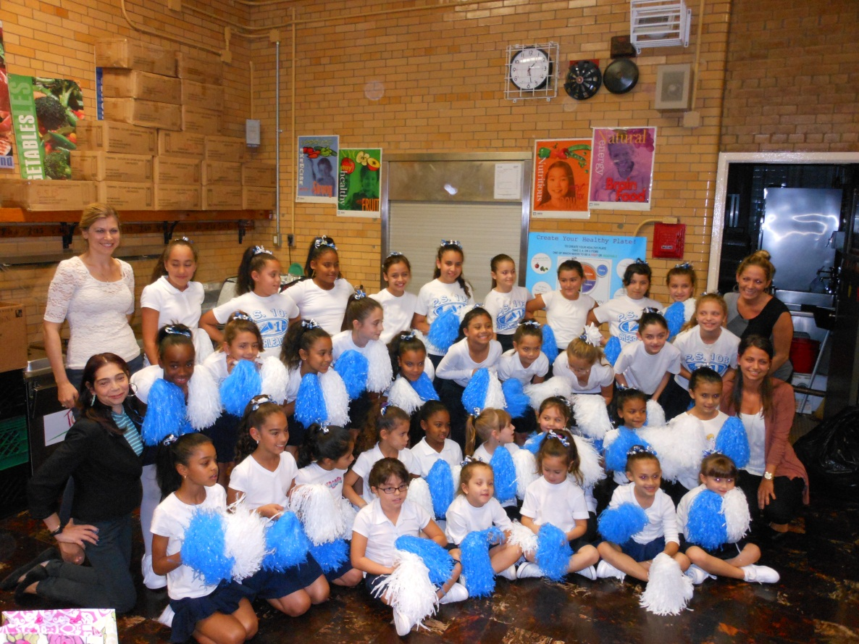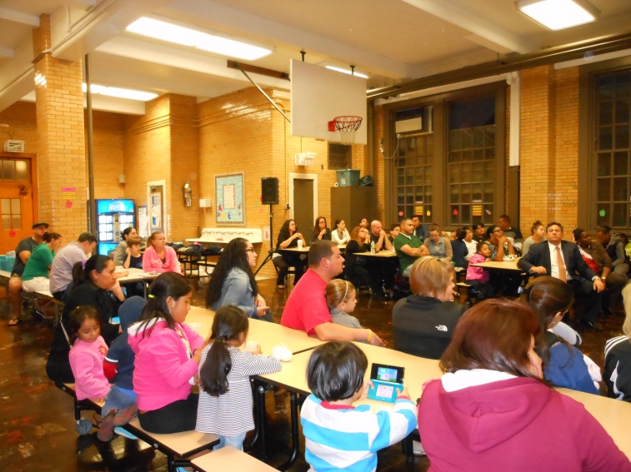

**Photos from the**

**PTA meeting**